
Cairo University

Faculty of Computers and Artificial Intelligent

CS251 - Software Engineering I

School Connect System
Software Requirements Specifications (SRS)

Phase 1
Code Champions

Nov & 2025

Contents
Team .......................................................................................................................................................... 2.
Document Purpose and Audience ............................................................................................................. 3.
Introduction ............................................................................................................................................... 3.
Software Purpose
Software Scope
Definitions, acronyms, and abbreviations
Requirements ............................................................................................................................................. 4.
Functional Requirements
Non Functional Requirements
System Models ............................................................................................................................................ 5.
Use Case Model ...................................................................................................................................... 6.
Use Case Tables UC1, UC2, UC3 ………………………………………………………….………………………………………………… 6,7.
Use Case Tables UC1, UC2, UC3 ……………………………………………………………………….…………………………………… 7,8.
Use Case Tables UC1, UC2, UC3 ……………………………………………………………………………………….…………………… 8,9.

Ownership Report ....................................................................................................................................... 12.

ID | Name | Email | Mobile
20220791 | Faisal Hassan Saeed | 20220791@stud.fci-cu.du.eg | +966 57 817 3272
20220995 | Mohamed amir | 20220995@stud.fci-cu.du.eg | +20 111 890 2965
20220808 | Mazin Hussain | 20220808@stud.fci-cu.edu.eg | +20 155 609 8977
20220869 | Abdulrahman Mohamed Mohamed abdalla | 20220869@stud.fci-cu.du.eg | +20 104 093 7893
20220922 | AlaEldin Ali MohammedToum | 20220922@stud.fci-cu.du.eg | +966 56 249 6447

1. Introduction
Campus Connect is a dedicated social platform for school students and staff. It enables academic collaboration, sharing of resources, and social engagement within campus communities.

2. Document Purpose and Audience
This document outlines the functional and non-functional requirements of the school system. It is intended for teachers and other stakeholders to ensure accurate implementation. This includes students, project team members, and teaching assistants.

3. Definitions and Abbreviations
SRS – Software Requirements Specification
FR – Functional Requirement
NFR – Non-Functional Requirement
UC – Use Case
UI – User Interface
MVC – Model View Controller

4. Problem Statement
School students face challenges forming meaningful connections in their academic communities. Campus Connect addresses this by providing features tailored to student life such as study groups, resource sharing, events, and communication.

5. Target Users
- School students
- School managers
- Website administrators system

6. Functional Requirements
- FR1: User registration and login system
- FR2: Profile management
- FR3: Create, edit, and delete posts
- FR4: Commenting on posts
- FR5: Search functionality (people, posts, and communities)
- FR6: Community creation and joining
- FR7: Direct messaging between users
- FR8: Sharing academic materials
- FR9: Reporting inappropriate content
- FR10: Admin moderation
- FR11: Notifications for posts and messages
- FR12: Viewing school services
- FR13: Display system errors and user actions

7. Non-Functional Requirements
- NFR1: Support at least 1000 concurrent users.
- NFR2: User interface must be simple and responsive.
- NFR3: Display user-friendly error messages.
- NFR4: Ensure data privacy and security with encryption.
- NFR5: Follow SOLID design principles.
- NFR6: Scalable for future growth.
- NFR7: Average response time should not exceed 2 seconds.

8. Use Case Diagram

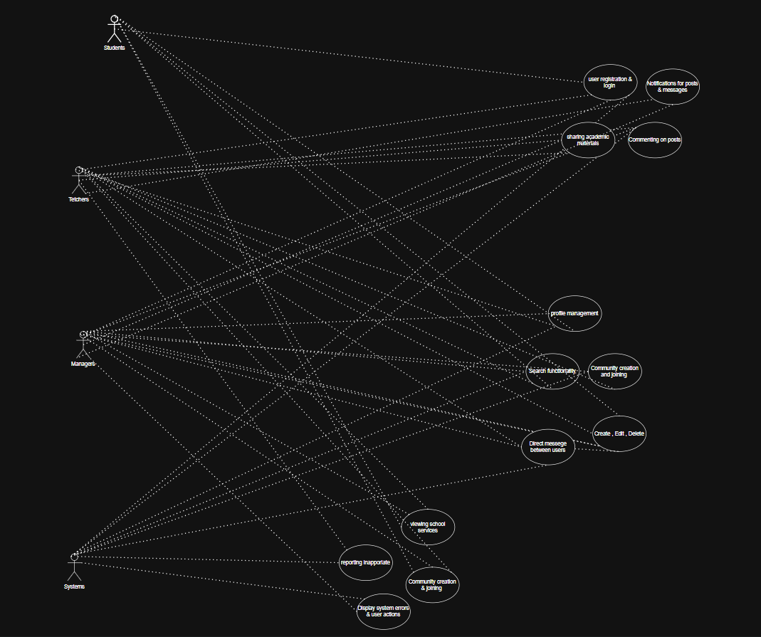

Use Case Tables

Use Case ID: | UC1, UC2, UC3
Use Case Name: | Register/Login, Profile management, Search functionality
Actors: | Student  teachers  managers  System
Pre-conditions: | User has access to the School system.  User has credentials (or intends to create new account).
Post-conditions: | System authenticates user or creates accounts.  User can search, edit the profile page.
Flow of events: | User Action | System Action
Flow of events: | 1- User Enter Card and Password. | 1- System verifies user credentials
Flow of events: | 2- User clicks Login/Create Account | 2- System Verify user data
Flow of events: | 3- User Select id from the list | 3- System loads homepage
Flow of events: | and so, on | 4- System retrieves student info
Exceptions: | User Action | System Action
Exceptions: | - User Enter incorrect id  - and Password. | 1- System return error massage
Exceptions: | User cancels login | - Return to home page.
Includes: | (UC1) (UC2) (UC3)
Notes and Issues: | Ensure encryption is applied when user enters credentials.  UI should provide clear error messages for invalid inputs.  Consider timeout handling for login attempts

Use Case ID: | UC3, UC8, UC13
Use Case Name: | Create/Edit, Direct messages, Notifications
Actors: | Teachers  Managers
Pre-conditions: | Users have access to the school system.
Post-conditions: | System authenticates user or creates accounts.  User can see the authenticates in direct messages between them .
Flow of events: | User Action | System Action
Flow of events: | 1- User Edit or Create name or password . | 1- System allowed user to change
Flow of events: | 2- User clicks delete Account | 2- System allowed user to delete
Flow of events: | - Users send notification to all student | 3- System allowed to …
Exceptions: | User Action | System Action
Exceptions: | 1- User clicks hide notification | 1- System stop sharing notifcations
Includes: | (UC3) (UC8) (UC13)
Notes and Issues:

Use Case ID: | UC9
Use Case Name: | Reporting inappropriate content
Actors: | Teachers  Systems
Pre-conditions:
Post-conditions:
Flow of events: | User Action | System Action
Flow of events: | 1- User Enter Card and Password. | 1- System verifies user credentials
Flow of events: | 2- User clicks Login/Create Account | 2- System Verify user data
Flow of events: | 3- User Select id from the list | 3- System loads homepage
Flow of events: | and so, on | 4- System retrieves student info
Exceptions: | User Action | System Action
Exceptions: | - User Enter incorrect id  - and Password. | 1- System return error massage
Exceptions: | User cancels login | - Return to home page.
Includes: | (UC9)
Notes and Issues:

Use Case ID: | UC10
Use Case Name: | Admin moderation inappropriate content
Actors: | Managers
Pre-conditions: | Managers has access to add or block users.
Post-conditions: | Can block or add successfully.
Flow of events: | User Action |  | System Action
Flow of events: | 1- Managers Add users |  | 1- System ask them about user id
Flow of events: | 2- Managers block users |  | 2- System reply with Confirmation message
Exceptions: | User Action |  | System Action
Exceptions: | 1-Manager add or block incorrect user |  | 1- System return error massage
Includes: | (UC10)
Notes and Issues:

Ownership Report

Item | Owners
Functional requirements & non requirements  + use cases tables | Faisal Hassan
Functional requirements & non requirements  + use cases tables | Mohamed amir
Use cases diagrams | Mazin Hussain
Use cases diagrams | Abdulrahman Mohamed
1,2,3,4,5 | AlaEldin Ali MohammedToum

https://github.com/mohammed0335/Campus-Connect-/tree/main

